MyMenu Project Report

Group21

Group Members: Ghalia Alshanbari - U53991913

Lamya Alzahrani - U57771896

Basil AlGhamdi - U83504848

Mohammed Asiri - U23049787

2-

# Table of Contents

Table of Contents 2

3- Project Definition 3

4- Project Objective 4

5- Stakeholders List 5

6- Use Case Diagram 6

7- Selected Use Case Descriptions 7

8- Sequence Diagrams 8

Detailed Sequence Diagram for use case: new menu. 9

9-System Architecture 10

10-Detailed Class Diagrams 11

11- State-machine diagram 12

12- ER- Diagram 13

13-Github Link 14

14- Conclusion 15

15- References 16

16- Appendix A 17

Project Work breakdown Structure 17

17- Appendix B 18

Task Assignment Matrix 18

18- Appendix C 19

Sample of Commits 19

# 3- Project Definition

For our project, we made an automated menu system for 10 restaurants in the Boston Area. Our project allows customers to optimize their ordering experience without worrying about dietary, religious, or health restrictions. For example, an individual who is vegan with a peanut allergy could register this information into the app, and all foods that this individual cannot eat will be removed from the menu. This way, the system helps the customer in avoiding a life-threatening reaction and wasting money on food they are unable to consume as well as avoiding the hassle of making sure your food doesn’t consume any ingredients you are allergic to.

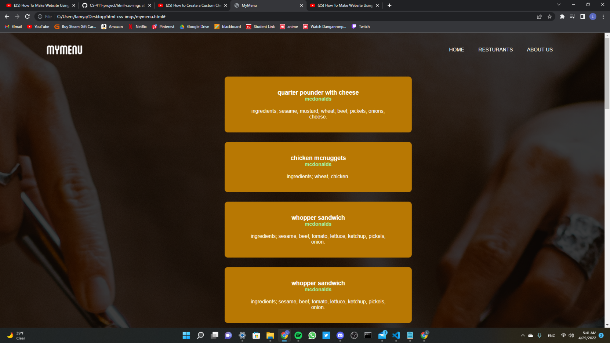

# 4- Project Objective

Our project’s objective is to make the food ordering process simpler for customers in the Boston area with food restrictions from food allergies to dietary preferences while also easing their minds while ordering and making sure the food they order doesn’t contain any food they are allergic to or food they choose not to consume such as Halal food. The project will also aid restaurants in increasing their revenue by growing their customer attraction and limiting the waste the restaurants might produce by cooking food for customers that can’t consume it.

# 5- Stakeholders List

External stakeholders:

|  |  |
| --- | --- |
| Stakeholder | Success/ Acceptance criteria |
| Customer | Enhance the userd experience, making their ability to order food be as frictionless as possible. Essentially, making it easier for the user to find the food that satisfies their dietary, religious, or health restriction as easy as possible. |
| Restaurant | Since customers will have to order food catering to their dietary restrictions, restaurants can use information from the app to cater more to individuals with food restrictions. Also, it will reduce costs since restaurants will buy less produce and waste less uneaten food that cannot be consumed by the customers. |

Internal Stakeholders:

|  |  |
| --- | --- |
| Stakeholder | Success/Acceptance criteria |
| MyMenu Website | Create a program that is easy to navigate for the customer in order to maximize their experience and generate more customers usage. As well as create enough revenue for the restaurant. |

# 6- Use Case Diagram

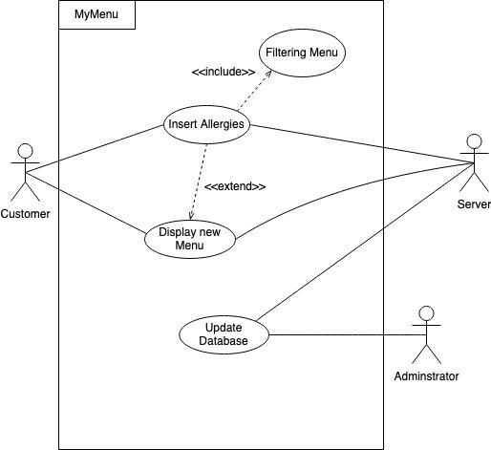

Figure 1

The customer Inserts their allergies to the MyMenu program which then the server registers these allergies and the administrator updates the database accordingly. Then the menu is filtered to exclude any items that might contain the customer's allergies. The new menu is then displayed to the customer.

# 7- Selected Use Case Descriptions

|  |
| --- |
| Use Case Name: New Menu |
| Actors: Customer, Server |
| Stakeholders: Customer, Restaurant, MyMenu Program |
| Triggering Event: Customer inserts allergies to get new Menu |
| Steps Preformed:  1- Customer opens the MyMenu Program  2-Customer Inserts Allergies  3- Customer clicks the filter option  4-The Server Updates the Menu  5- Server displays the new Menu to the customer |
| Preconditions: Must insert allergies before getting a new filtered menu, must be a registered allergy, must click the filter option. |
| Postcondition: The Customer gets the new filtered menu. |

|  |
| --- |
| Use case name: Database update |
| Actor: Server, Administrator |
| Stakeholders: Server, Restaurant |
| Triggering Event: Administrator is trying to update the database |
| Steps preformed:  1- Administrator accesses the databases  2- Administrator updates the database  3- Administrator closes the database |
| Preconditions: Must be a registered administrator, the database needs updating |
| Postcondition: Database is updated. |

# 8- Sequence Diagrams

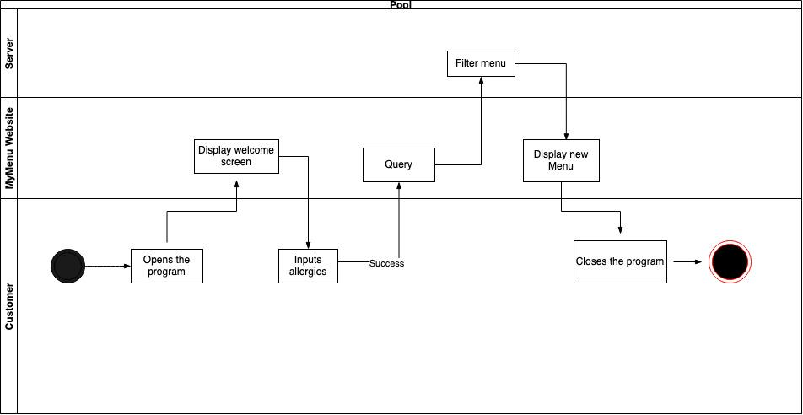

Figure 2

This diagram has multiple swim lanes to represent the customer, MyMenu website and the server. The customer opens the program, taken to a display screen where they input their allergies and if that is a success then the menu is filtered and displayed to the customer. After that the customer closes the program.

# Detailed Sequence Diagram for use case: new menu.

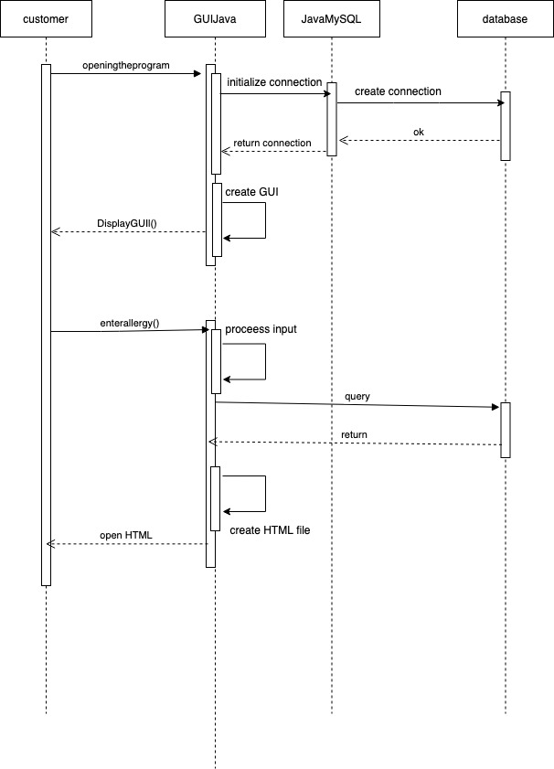

Figure 3

This is the detailed sequence diagram for the use case of new menu. Here we use the GUIJava and JavaMySQL to help with initializing, creating, and returning the connection. Then the GUI is displayed and the allergy is entered which then the process is imputed and returned. Then create the HTML file and then open the HTML.

# 9-System Architecture

MyMenu Website uses the Repository Architecture because it consists of a database that is our central data structure that contains each restaurant and their menus with the ingredients of each item on the menu respectively. Each restaurant’s menu can be seen as a collection of independent components that answer to the central database that serves each of these restaurants and their menus. The repository is used here because this system contains a large amount of information that must be stored in an efficient way.

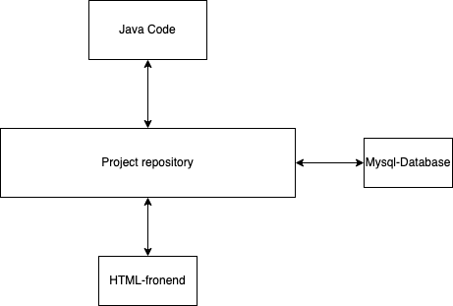

Figure 4

# 

# 10-Detailed Class Diagrams

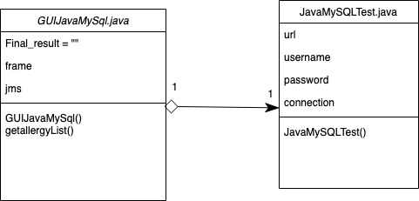

Figure 5

We have two classes in our project: a GUIJavaMySQl class and a JavaSQLTest class they each have their own respective objects and their methods. The JavaSQLTest class has an association relationship with the GUIJavaMySql class and the clear diamond represents the source side of the relationship between these two classes. There is only one instance either way.

# 11- State-machine diagram

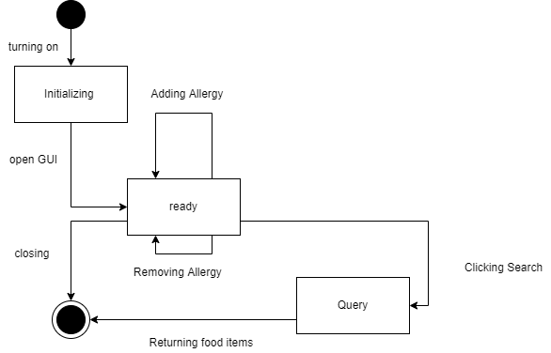

Figure 6

It starts with turning on the program which then initializes the state. After the program is initialized a GUI opens and the program enters a ready state. In this state, the customer adds and deletes allergies, and it won’t affect the state of application. Whenever the search button is clicked the application enters the query state after and after it finishes it returns a new menu to the customer while following the constraints.

# 12- ER- Diagram

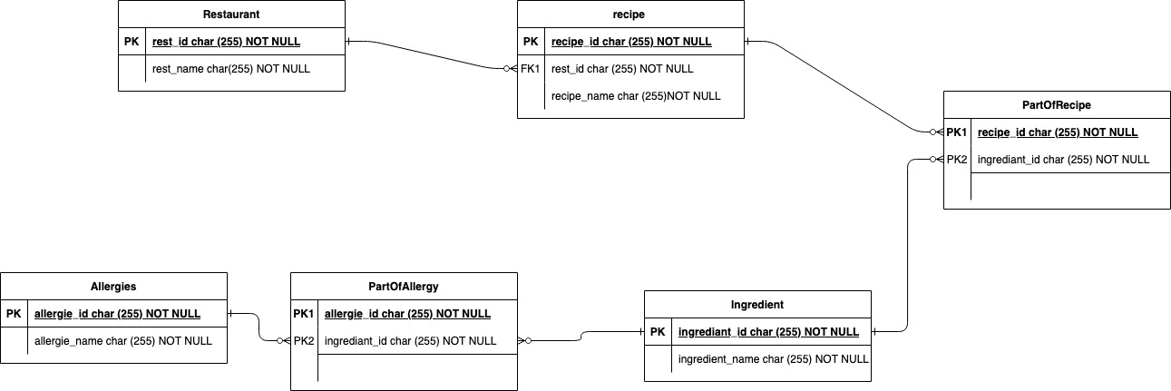

Figure 7

Each restaurant has at least one recipe and each recipe has only one restaurant. Each recipe has many parts of recipe and each part of recipe has only one recipe. Each ingredient has many parts of recipe and each part of recipe has only one ingredient. Each ingredient has many parts of allergy and each part of allergy has only one ingredient. Each part of allergy has one ingredient and each allergy has many parts of allergy.

# 13-Github Link

<https://github.com/llamya/CS-411-project>

Above is the GitHub link with all the commits for our MyMenu Program.

# 

# 14- Conclusion

The MyMenu project has been a very informative journey for our software engineering experience. This was most of our first times dealing with databases and creating a program. We first struggled with putting all the knowledge we learnt from this course and previous computer science classes together. But, after brainstorming and getting to work we found that much of what we learnt during our undergrad years has prepared us for getting to this point in our degree. We learnt how to structure our program in an efficient way as well as time management and making sure everyone had a part in everything. If someone was having a tough time in one area we would all try and figure out a way to help. This made us learn from correcting the mistakes of each other. As well as if we made the mistake we know now what we did wrong and we won’t repeat this mistake in the future. This has helped us overall to gain experience and know our strengths and our weaknesses when it comes to software engineering. Overall, this project has made us all better computer science students and I’m sure we will use the knowledge we gained in our future perspective careers.

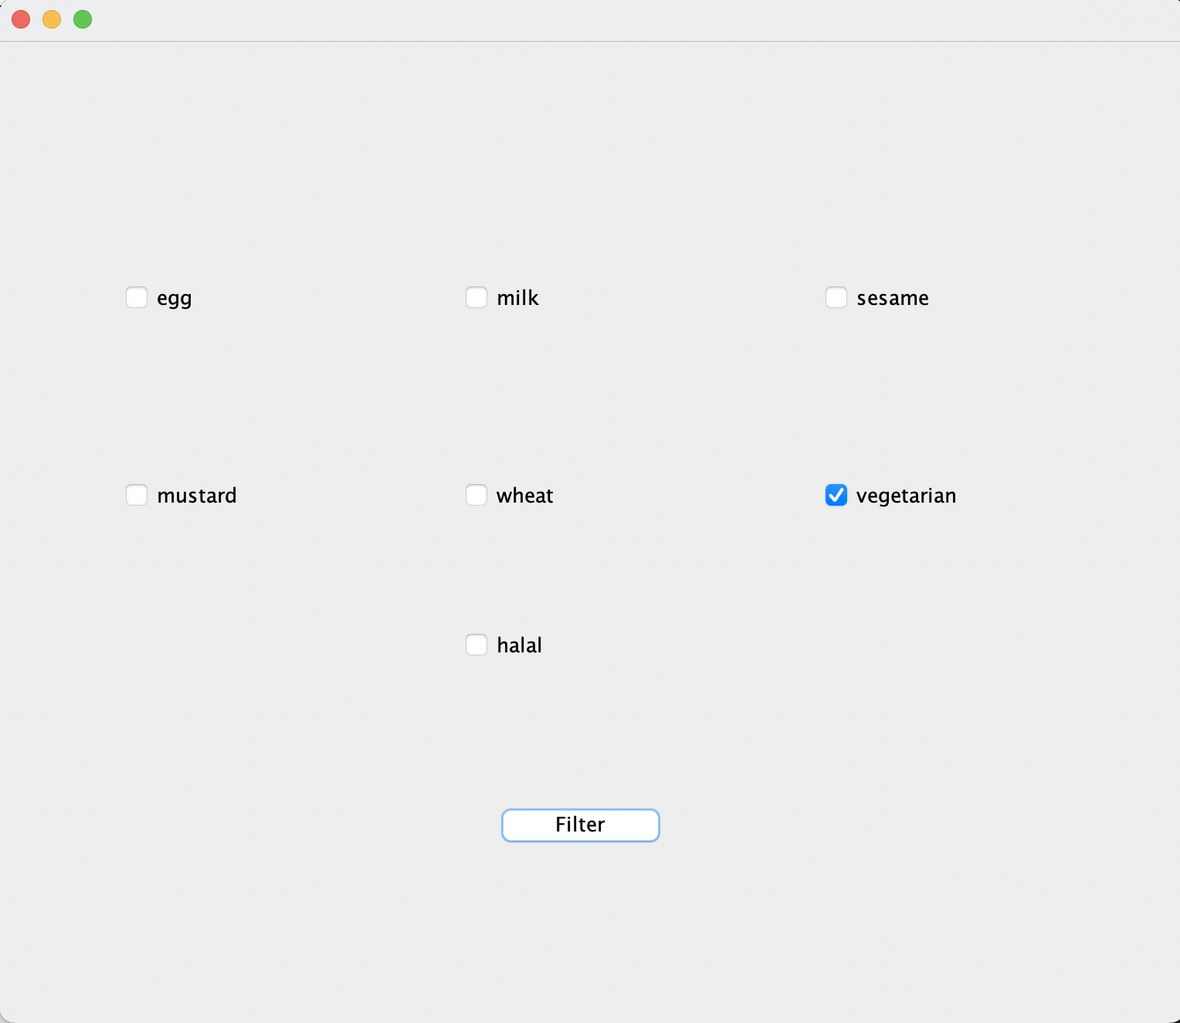



# 15- References

“ Pandaexpresswebsite Files Pdf Nutrition.pdf: Food Allergies, PDF, Nutrition.” *Pinterest*, 23 July 2016, www.pinterest.com/pin/353743745714730888/.

“Allergen Info.” *Taco Bell Allergen Information*, www.tacobell.com/nutrition/allergen-info.

*Allergen Information - Burger King®*. origin.bk.com/pdfs/allergens.pdf.

*Burgers & Sandwiches - Shakeshack.com*. shakeshack.com/sites/default/files/2021-03/SHA_AllergenFacts_ShakeShack-%202021.pdf?source=post_page---------------------------.

*Chick-Fil-A Nutrition Facts Chart - Wahazel.com*. www.wahazel.com/hazelcares/pdf/fastfoodnutrition/Chick-fil-A.pdf.

*Food Allergies and Sensitivities - KFC*. www.kfc.com/food-allergies-and-sensitivities.

Ibrahim, Ahmed. “CS411: Software Engineering Lecture 3.” Boston University.

Ibrahim, Ahmed. “CS411: Software Engineering Lecture 6.” Boston University.

*Java Checkbox ️ - Youtube*. www.youtube.com/watch?v=GwxvLzQoMYM.

*KFC Ingredients Listing*. www.kfc.ca/Content/OnlineOrderingImages/StaticPage/IngredientListingAugust2020.pdf.

*McDonald’s UK Allergen*. www.mcdonalds.com/content/dam/uk/pdf/nutrition/allergen-booklet-24062020.pdf.

*Nutrition Guide Limited Time Products - Dunkindonuts.com*. www.dunkindonuts.com/content/dam/dd/pdf/nutrition.pdf?source=post_page---------------------------.

“Sandwiches.” *Welcome to Five Guys*, www.fiveguys.com/menu/Sandwiches.

*US Nutrition for Website - Tlcsurgery.com*. www.tlcsurgery.com/wp-content/uploads/2016/01/Wendys.pdf.

# 16- Appendix A

## Project Work breakdown Structure

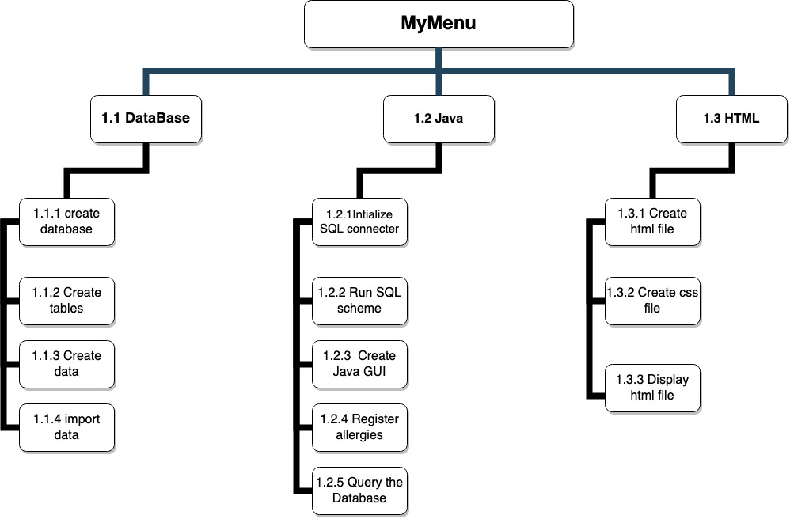

Figure 7

We have three main tasks in our work breakdown structure. The Database which has 4 subtasks that helps us connect our data components. Second we have Java which acts as our connector and registered the information. Lastly third we have HTML that helps us create the CSS file and the display HTML file.

# 17- Appendix B

## Task Assignment Matrix

Task Task Owner Support

Create database Lamya Basil, Mohammed, Ghalia

Java SQL connecter Mohammed Basil, Ghalia, Lamya

Java GUI Basil Lamya, Mohammed,Ghalia

HTML page Lamya Basil, Mohammed, Ghalia

Project Report Ghalia Basil, Mohammed,Lamya

Project Presentation Ghalia Basil,Mohammed, Lamya

# 18- Appendix C

## Sample of Commits

